CHRISTIANIA RESEARCHER in RESIDENCE

WATCHING THE DANISH GOVERNMENT

Jonathan Trayner

By the time you read this I will be gone (or at least in the airport being probed by security), my name is Jon Trayner and I was the grandly titled Christiania Researcher in Residence from the 20th January until 1st February. Like I suppose the majority of people who come here I was greatly interested in how Christiania worked, what it was about, and what it could teach the rest of us.

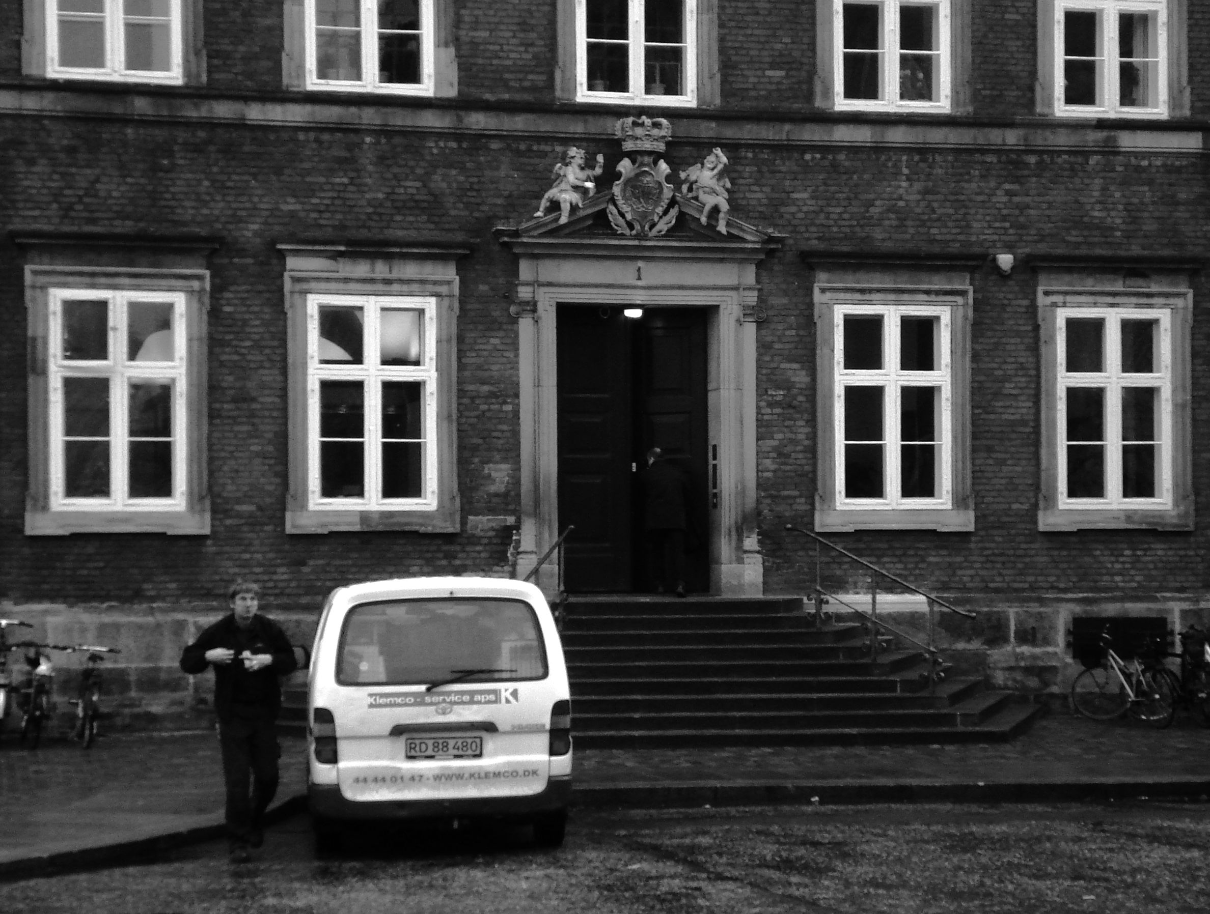

My initial proposal to the programme was based on the idea of Psychogeography (a term that was coined by Guy Debord of the Situationist International) a way of looking at the relationship between the city and the people who live there and how these feed into each other. I suggested that there was a link between Christiania’s former existence as a military installation and the fact that it is currently ‘under siege’ by the Danish authorities. When I explained this idea to one christianite he told me that when the bastions that form Christiania were part of the defences of Copenhagen, they were left wooded in times of peace; the locals were allowed to use them as a source of fire wood etc. But when there was a war the trees were cleared and cannons set up. My source pointed out that Denmark is now (like the UK where I am from) at war with Terror and therefore the bastions need to be cleared…

I quickly came to realise two things; firstly that the two weeks I was here was not going to be long enough to come up with anything but the most superficial of surveys and secondly I was perhaps interested in something else after all. While walking round the site I realised that I did not want to look at Christiania but from it, this place has so many observers wanting to learn its supposed secrets, either friendly or not, and I did not feel that I wanted to do this. I did not have the time or perhaps the skills to engage in this particular discourse.

Looking from Christiania then; I was interested in the whole ‘paranoia’ about surveillance that we all have, combined with the collection of huge amounts of unnecessary data that governments and companies store on our actions and movements. This is particularly close to the surface in a place like Christiania at a time like this when everyone is concerned about who knows what and how it can be used to coerce them into a path they do not wish to follow. I decided therefore to counter-attack, to go out into Copenhagen and secretly film the people going in and out of various government buildings, mainly parts of the Finance Ministry as they now deal with Christiania. This was for me a form of symbolically redressing the balance; you film us, we film you; although I am not a christianite I am living here as a guest and feel entitled to this particular ‘us’.

What will the end result be? I am not sure. I will end up with at least 5hours of footage of the various buildings, and then it will be a case of editing things so that it produces something interesting. I have produced a short extract that can be seen on the CRIR website and hopefully I will have the opportunity to come back and exhibit the final artwork here when it is finished.

To see the footage follow the link from www.crir.net, I would be interested to hear any feedback that anyone wishes to send to me, please email jon@trayner.org with your views.

